PRESS RELEASE
4/25/2016

The Long Night of Research: FACC celebrates saving six billion gallons of jet fuel

Ried im Innkreis, April 25, 2016 – Once again, FACC was one of the most popular Upper Austrian exhibition venues for the Long Night of Research this year. During the course of this event, 1.235 guests gained an exclusive insight into the fascinating world of aviation. The main focus of this year’s event was “green flying”. Aviation Partners Boeing recently passed the milestone of 6 billion gallons, or 22.7 billion liters, of jet fuel saved. Innovations from FACC have played a major role in making this possible. The company develops high-tech products that make aircraft up to 20 percent lighter and more efficient.

There was plenty of high-tech made in Austria to be admired at FACC during the Long Night of Research. From insights into the company’s development activities through to a presentation of the production processes for high-strength composite components and guided factory tours, FACC offered its guests a diverse program. The aircraft equipment supplier based in Ried im Innkreis is one of the world’s leading manufacturers of lightweight components for the civil aviation industry. Companies such as Airbus and Boeing appreciate the expertise of the Upper Austrian experts. More than 1.200 visitors took advantage of the opportunity to attend this popular event. At the same time, guests were able to share in a very special milestone in “green flying”.

6 billion gallons of jet fuel saved

“The Long Night of Research was the ideal occasion to celebrate this milestone in the history of sustainable air travel,” says FACC’s COO Robert Machtlinger. The milestone was signaled by the “fuel savings counter” when it passed the six billion mark on April 12. This counter – to be found at www.aviationpartnersboeing.com – records in real time how many gallons of jet fuel can be saved thanks to state-of-the-art technology. “We are not responsible for every innovation in the aviation industry, of course, but a substantial share of these six billion gallons is certainly down to us,” explains Machtlinger. This is because the savings are attributable to Blended and Split Scimitar Winglets, which have been developed and produced by FACC for various types of aircraft from Boeing and Dassault. Aviation Partners Boeing expects the next milestone, the 10 billion gallon mark, to be passed in 2019. The technologies that make such significant savings possible with relatively minor adaptations to aircraft took center stage at the Long Night of Research.

Guided tours through production and innovation

Naturally, the interest of the many guests was focused on the products from FACC. Every company department provided exhibits for the event, while specialists from the FACC Crew passed on their knowledge in the form of guided tours. Highlights from FACC’s three divisions were presented at several stations. From the aircraft fuselage and wings to engine components and the passenger cabin, there were plenty of exhibits for the visitors to admire. The staff explained how new technologies came into being and how these lead to new standards in the aviation industry. Children were introduced to the company’s work in a playful way and allowed to demonstrate their skill as “tomorrow’s researchers”. A flight simulation that impressively presented visitors with the perspective of a Red Bull Air Race pilot was also very popularity. During this Long Night of Research, FACC illustrated the many facets of aircraft research and demonstrated the dream of flying to young and old.

About FACC
FACC AG is one of the world’s leading companies in the design, development and production of advanced fiber reinforced composite components and systems for the aviation industry. Their range of products reaches from structural components for the fuselage and wings to engine components to complete passenger cabins for commercial aircraft, business jets and helicopters. FACC is a supplier to all large aircraft manufacturers such as Airbus, Boeing, Bombardier, Embraer, Sukhoi, and COMAC as well as for engine manufacturers and sub-suppliers of manufacturers.

In the 2014/15 business year FACC achieved an annual turnover of 528.9 million euros. The company employs a staff of around 2,800 employees in Austria. More information is available at www.facc.com.

We are at your service for any enquiries:

Anja Bichlbauer
Project Manager Communications
Fischerstrasse 9
4910 Ried im Innkreis, Austria
Phone: 43 59 616-1137
Email: a.bichlbauer@facc.com

Picture information:
Pictures can be downloaded along with the press kit in the press release on our website at www.facc.com. Photos: FACC (free)

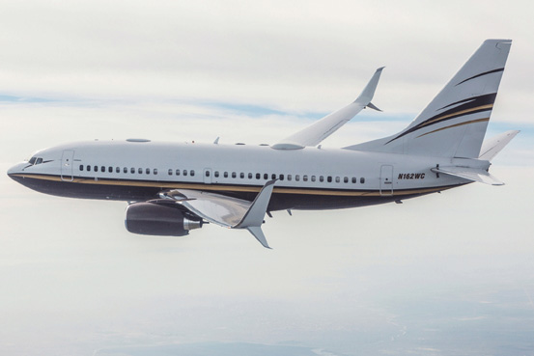
The Split Scimitar Winglets made by FACC optimize aerodynamics, thereby ensuring substantial jet fuel savings. Photo rights: Aviation Partners Boeing (free of charge)

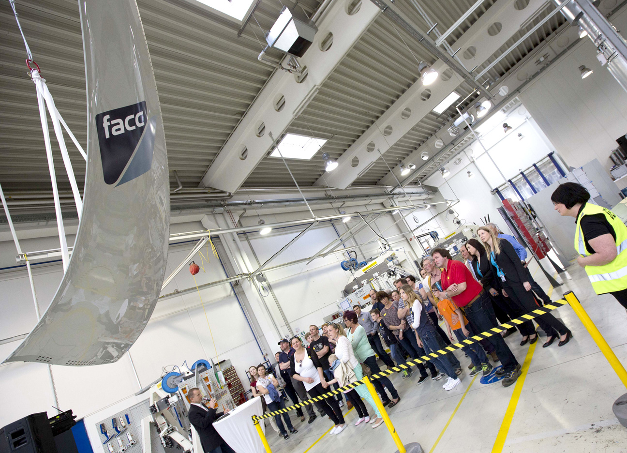

More than 1,200 guests took up the FACC invitation to take part in the “Lange Nacht der Forschung” (long night of research) on 22nd April 2016 and enjoyed an exclusive insight into the fascinating world of aviation.
Picture: FACC AG/Alois Furtner (free)

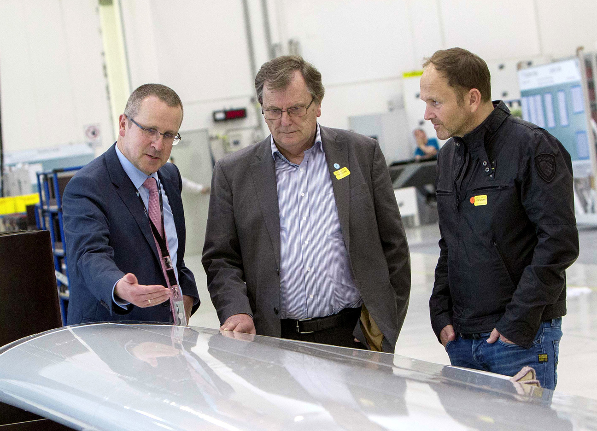

FACC CTO Robert Machtlinger (left) at the “Lange Nacht der Forschung” (Long Night of research) on 22nd April 2016 with Bezirkshauptmann (district governor) for Ried im Innkreis, Dr. Franz Pumberger (centre) and Andreas Fill (right) from Fill Maschinenbau.
Picture: FACC AG/Alois Furtner (free)

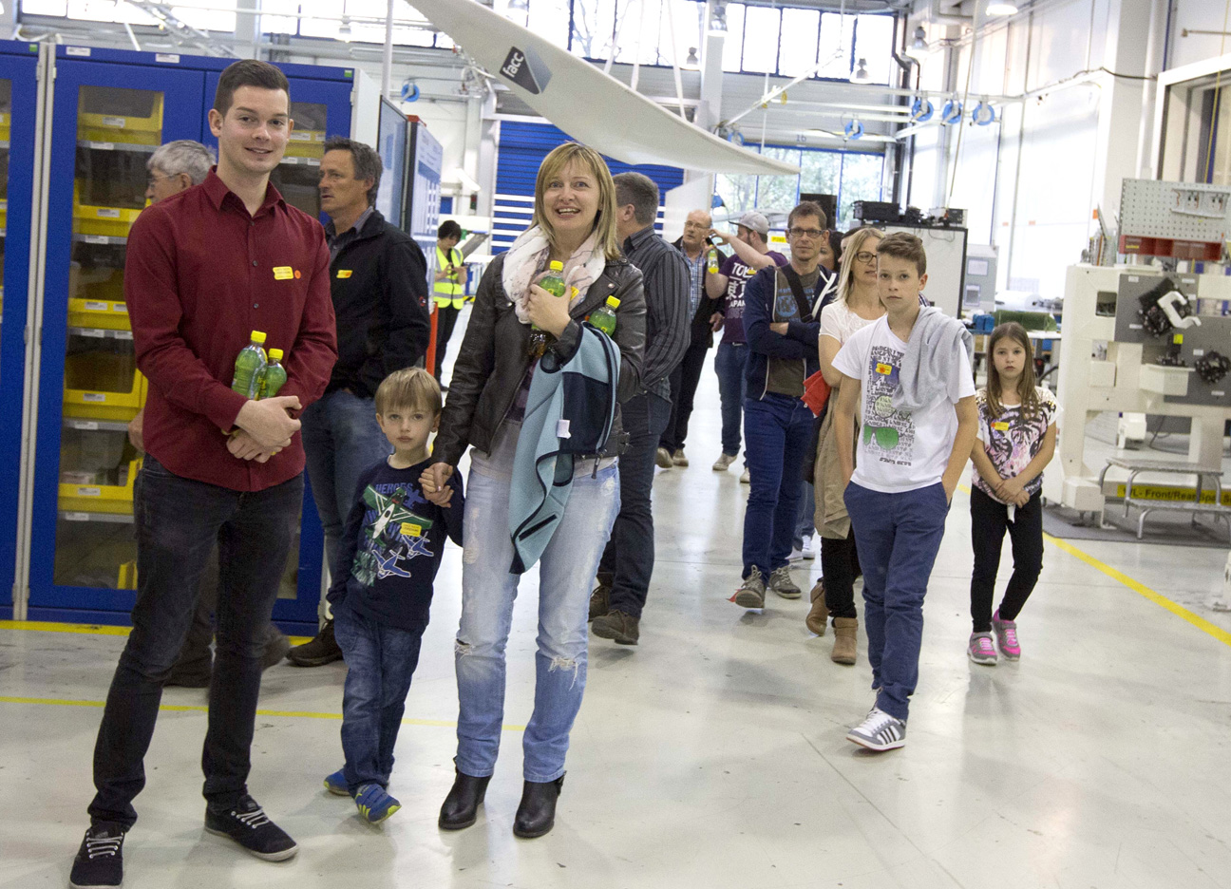
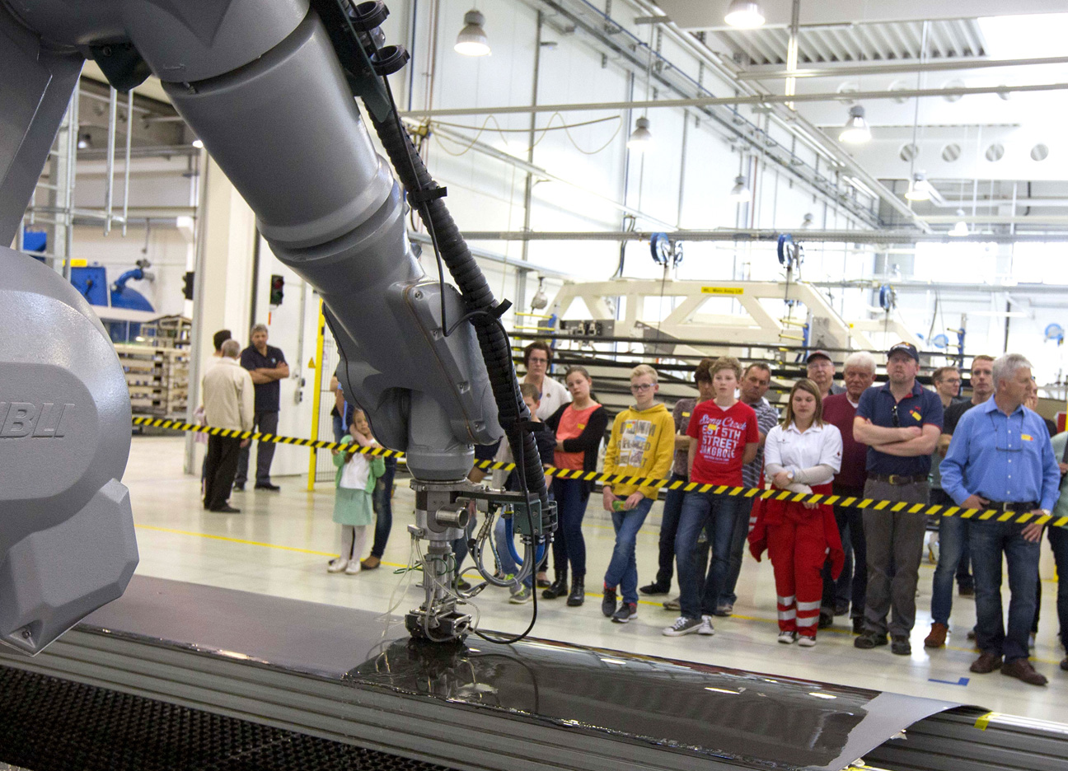
Pictures: FACC AG/Alois Furtner (free)

